Practice Makes a Man Perfect

Long ago, there lived an archer named Uthaman. During his time, the forests and animals filled the lands. He was a skilled archer and could perform wonderful feats of archery. He could hit the centre of the target precisely, no matter how far the target was. He was also a show off. He liked to show his skills for the crowds to admire. One day, as usual, he was shooting arrows at the targets. The admirers watched in awe. At that time a man with a beard as white as snow, carrying oil gourds, joined the crowd and stood at the back. As Uthaman finished, the crowd clapped and cheered for him except the oil seller. He neither clapped nor cheered. Suddenly with a deep and loud tone, he said, “It’s just a matter of practice!” Uthaman got annoyed. The irritated Uthaman asked, “Are you an archer? Do you think anyone can do what I do?” The old man said calmly, “No sir, I am not an archer. I don’t doubt your skills. All I said was that, everything was a matter of practice.” Uthaman was red in anger. “What do you know to pass such thoughtless comments on others? Who are you?”

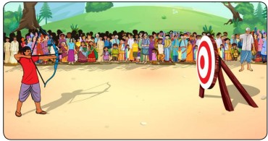
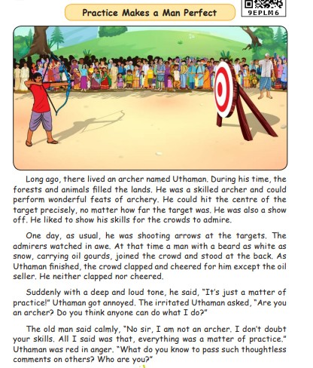
Model Odt

